Mouse FARESHARE
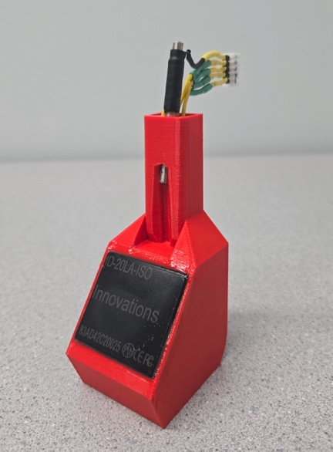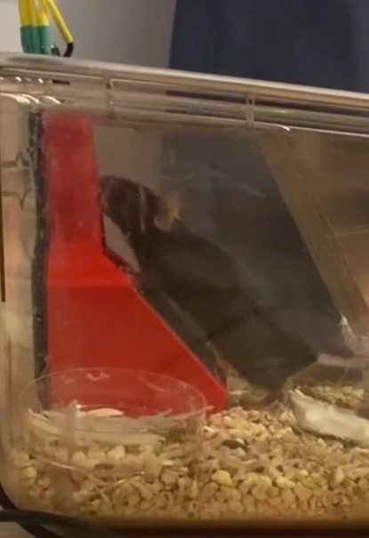
The mouse version of FARESHARE includes two notable design changes:

- The scanner is now located below the subject such that the RFID tag can be placed on the chest. This frees the head for in vivo neural manipulation and recording.
- Each lick now activates the motor such that increasing lick frequency increases fluid delivery. This means the licking microstructure is more meaningful, as the licking is driving fluid delivery, rather than just subject presence (with constant flow) as was the case previously.

The only major changes in instrumentation are the RFID housing print file, the scanner, and the straw.

The housing is now a single print. If printed upright (i.e. the direction it will be when used), it does not require any supports. We tried other designs, but mice would either find ways to cover the scanner, not align the tag properly, or just not use it.

The scanner used is now the larger ID20LA:
https://www.sparkfun.com/products/11828
Alternatively, ID20LA-ISO can be ordered directly from ID Innovations:
https://www.id-innovations.com/Modules(non%20write).htm
This is the same scanner but is compatible with the more standard ISO RFID tags that are commonly used in pets.

The straw is much smaller than the one used previously in rat version. We used these: https://www.amazon.ca/Unifizz-Stainless-Capillary-Seamless-Decoration/dp/B09PCY1L8N/ref=sr_1_13?keywords=stainless%2Bsteel%2Btube%2B3.2mm%2Bid&sr=8-13&th=1)
However, any 3.2mm ID, 4mm OD straw that is conductive will work. We cut them down to 5cm long with a Dremel. This size has the advantage of making a good seal with the tubing such that fluid does not drip through the straw, and rather is released in a more controlled droplet at the tip of the straw.

